**Student t Distribution**

Assume that a random variable *Z*has the [standard normal distribution](http://www.r-tutor.com/node/58), and another random variable *V*has the [Chi-Squared distribution](http://www.r-tutor.com/node/60) with *m* *degrees of freedom*. Assume further that *Z*and *V*are independent, then the following quantity follows a **Student t distribution**with *m*degrees of freedom.

t = ∘-Z-- ~ t(m )
     V ∕m


Here is a graph of the Student t distribution with 5 degrees of freedom.

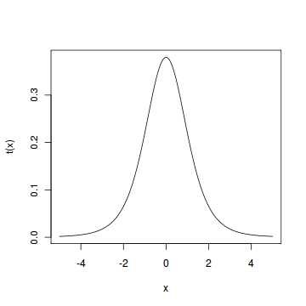

#### Problem

Find the 2*.*5*th* and 97*.*5*th* [percentiles](http://www.r-tutor.com/node/38) of the Student t distribution with 5 degrees of freedom.

#### Solution

We apply the quantile function qt of the Student t distribution against the decimal values 0.025 and 0.975.

> qt(c(.025, .975), df=5)   # 5 degrees of freedom   
[1] -2.5706  2.5706

#### Answer

The 2*.*5*th* and 97*.*5*th* percentiles of the Student t distribution with 5 degrees of freedom are -2.5706 and 2.5706 respectively.